
RAMAIAH
Institute of Technology
USN | 1 | M | S

(Autonomous Institute, Affiliated to VTU)
(Approved by AICTE, New Delhi & Govt. of Karnataka) Accredited by NBA & NAAC with ‘A’ Grade

SEMESTER END EXAMINATIONS – MAY/JUNE 2018

Course & Branch | : | B.E. : Electrical and Electronics Engg. | Semester | : | VI
Subject | : | Power Systems - I | Max. Marks | : | 100
Subject Code | : | EE61/EE601 | Duration | : | 3 Hrs

Instructions to the Candidates:
- Answer one full question from each unit.

 |  | UNIT- I
1. | a) | List the advantages of per unit system. | CO2 | (04)
 | b) | A synchronous generator and motor rated 30MVA, 13.2kV and both have subtransient reactance of 20%. The line connecting them has a reactance of 10% on the base of the machine ratings. The motor is drawing 20MWat 0.8 pf leading. The terminal voltage of the motor is 12.8kV. When a symmetrical 3 phase fault occurs at the motor terminals at p, find the subtransient current in generator, motor and at the fault point. The equivalent circuit is shown in Fig. 1(b). Choose generator ratings as the base.  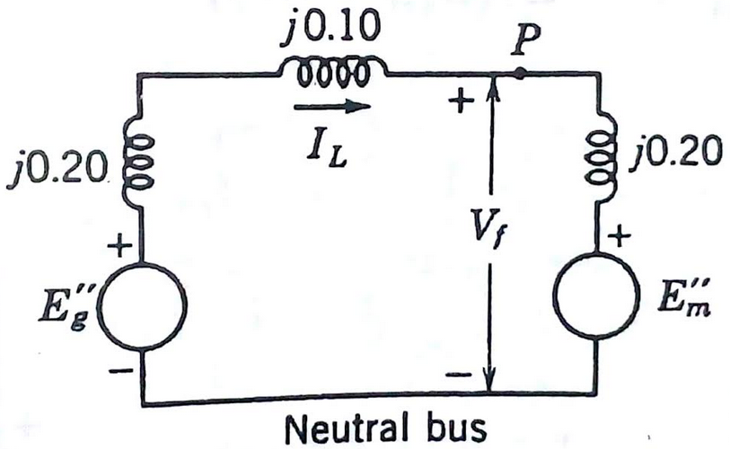  Fig.1 (b) | CO1 | (12)
 | c) | Explain the concept of complex power and the direction of power flow. | CO1 | (04)
2. | a) | A generator connected through a circuit breaker to a transformer is rated 100MVA, 18kV, with reactances of X_{d}”= 19% and X_{d}= 130%. It is operating on no load and rated voltage when a three phase short circuit occurs between the breaker and the transformer. Find i) the steady state short circuit current in the breaker ii) the initial sub-transient current in the breaker and iii) the maximum possible dc component of the short circuit current in the breaker. | CO3 | (12)
 | b) | Show that the pu impedance of a transformer is same whether it is referred to its LV side or HV side. | CO1 | (08)
 |  | UNIT- II
3. | a) | The currents flowing in the lines towards a balanced load connected in delta are I_{a} =100∟0⁰, I_{b}=141.4∟225⁰, I_{c} =100∟130⁰ A. Start by drawing phasor diagrams of the positive and negative sequence line and phase currents and find the symmetrical components of the given line currents. Find I_{ab} in Amperes from the symmetrical components of the given line currents. | CO4 | (12)
 | b) | Show that a balanced three phase system of voltage phasor contains only positive sequence components. | CO4 | (08)
4. | a) | The voltages at the terminals of a balanced load consisting of three 10Ω resistors connected in star are V_{ab} =100∟0⁰, V_{bc}=80.8∟-121.44⁰, V_{ca} =90∟130⁰ V. Assuming that there is no connection to the neutral of the load find the line currents from the symmetrical components of the given line voltages. Also find the power expended in the 10Ω resistors from the symmetrical components of currents and voltages. Phase sequence is abc. | CO4 | (10)
 | b) | Discuss the phase shifts of sequence components of voltages in the primary and secondary windings of a star-delta transformer with the help of phasor diagrams. Also explain the relevance of vector groups in transformers. | CO1 | (10)
 |  | UNIT- III
5. | a) | Write sequence network of the following:  - Synchronous generator  - Three phase transformer (Y-Y)  - Transmission line. | CO4 | (08)
 | b) | If a circuit is composed of 3 unsymmetrical impedances, then prove that the currents of one sequence do produce voltage drops of other sequences. | CO4 | (06)
 | c) | Why the neutral grounding impedance appears as 3Z_{n}in the zero sequence network. | CO4 | (06)
6. | a) | Draw positive, negative and zero sequence networks for the power system shown in Fig.6(a). Corresponding data is as given below.  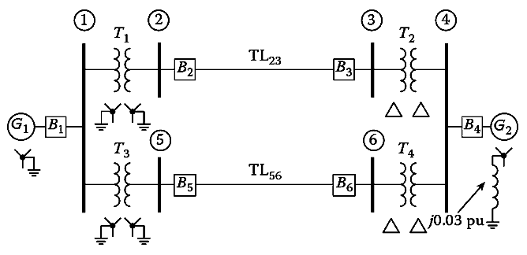  Fig.6(a)  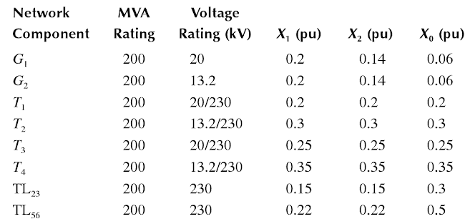 | CO4 | (14)
 | b) | Define sequence impedance and sequence networks. Obtain zero sequence diagram for various primary and secondary winding connection of three phase transformer. | CO4 | (06)
 |  | UNIT- IV
7. | a) | Obtain the sequence network representing a line-to-line fault on an unloaded generator. A salient pole generator rated 20MVA, 13.8kV, with X₁= 0.25pu, X₂= 0.35pu and X₀=0.1pu. The neutral of the generator is solidly grounded. Determine the sub-transient current in the generator and the line to line voltages for sub-transient condition when an L-L fault occurs on phases b and c at the generator terminal with the generator operating at rated voltage. Neglect resistance. | CO4 | (14)
 | b) | Briefly explain about unsymmetrical faults in a power system. | CO4 | (06)
8. | a) | A 25 MVA, 11kV, 3phase generator has a sub-transient reactance of 20%. The generator supplies 2 motors over a transmission line with transformer at both ends as shown in Fig.8(a). The motors have rated input of 15 and 7.5 MVA, both 10kV with 25% sub-transient reactances. Both the 3 phase transformers are rated 30MVA, 10.8/121kV, connection, Δ-Y, with leakage reactance of 10% each. The series reactance of line is 100Ω. Calculate the fault current when a single line to ground fault occurs at F on the line. The motors are loaded to draw 15 and 7.5MW at 10kV and 0.8pf leading. Assume that negative sequence reactance is equal to positive sequence reactance. The zero sequence reactance is shown in the figure. Assume generator ratings as the base.  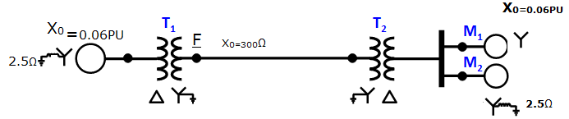  Fig.8(a) | CO4 | (15)
 | b) | Explain the inter connection of sequence networks for an LG fault on an unloaded generator through a fault impedance. | CO4 | (05)
 |  | UNIT- V
9. | a) | Derive the power angle equation for non-salient pole synchronous machine. | CO5 | (06)
 | b) | Explain the application of equal area criterion for the following cases:  - Sudden change in input  - Sudden loss on one of the parallel lines. | CO5 | (14)
10. | a) | Derive the swing equations with usual notations. | CO5 | (10)
 | b) | A loss free alternator supplies 50MW to an infinite bus, the SSSL being 100MW. Determine if the alternator will remain stable if the input to the prime mover of the alternator is abruptly increased by 50MW. | CO5 | (10)

****************

